Configuring caching in Apache superset using Redis.

Keywords: Superset, Redis cache, configuring cache in superset using Redis

Apache Superset

Apache Superset is an open-source software that can be used for data display and data visualization, and it is effective in processing large amounts of data.

Apache superset provides an interactive visualization and business intelligence capabilities with an interface simple enough for end users to create their own reports and dashboards

- It is a tool to visualize the data and explore the data. ​
- Superset allows the user to create and share dashboards. ​
- Superset tool is simple and doesn’t require programming skill and allows user to explore and organize data.

Superset provides
- An intuitive interface for visualizing datasets and crafting interactive dashboards
- A wide array of beautiful visualizations to showcase your data
- Code-free visualization builder to extract and present datasets
- A world-class SQL IDE for preparing data for visualization, including a rich metadata browser
- A lightweight semantic layer which empowers data analysts to quickly define custom dimensions and metrics
- Out-of-the-box support for most SQL-speaking databases
Advantages:

- Provides BI without needing code (need to know basic SQL). ​
- Easy and quick setup. ​
- Satisfies the needs of most companies to allows simple data analysis. ​
- Provides SQL-LAB that allows interactive querying.

Database support ​

- Superset supports most SQL databases, which allows you to access MYSQL, Oracle, MS SQL server and others.
- SQL-LAB allows you to select a database, schema and table and do an interactive query. ​
- Preview the data and also save the query history.

Configuring caching in Apache superset using Redis.

Redis:

- Redis or Remote Dictionary Server. It is an open source (BSD licensed), in- memory data structure store, used as a database, cache, and message broker.
- Redis provides data structures such as strings, hashes, lists, sets, sorted sets with range queries, bitmaps, hyper logs, geospatial indexes, and streams. ​

What is Redis Cache​

- Redis Cache is nothing but a Cache Management feature offered by Redis. Redis is normally used as a cache to store repeatedly accessed data in memory so that the user can feel the better performance of the application. ​
- The Redis Cache offers various features like how long you want to keep data, and which data to remove first, and some other bright caching models. ​

Advantage of using Redis Cache in Apache superset
​
- Redis Cache also minimizes the number of network calls made by your application, which in return improves performance of the application as a whole. One request from an application to the DB is similar to one network call. ​
- All Redis operations are atomic, which ensures that if two clients concurrently access, Redis server will receive the updated value. ​
- Avoid load on database​
- Speed up response for clients​
- A Boost in Performance​

How does the Redis Cache works?

- When we perform a DB retrieve operation via an Application, the Redis Cache stores the result in it’s cache. ​
- Further, when we perform the same retrieve operation, it returns the result from the cache itself and ignore the second call to database. ​
- Similarly, when we perform a DB update operation, the Redis Cache also updated the result in its cache. Needless to say, for delete operation also it deleted the data from the cache accordingly. In this way, there are no chances of getting incorrect data. ​

Configuring in Apache Superset

- Superset uses Flask-Caching for caching purpose.
- Flask-Caching supports various caching backend, including Redis, Memcached, SimpleCache (in-memory), or the local file system. Custom cache backend are also supported.
- Metadata cache: CACHE_CONFIG
- Charting data queried from datasets: DATA_CACHE_CONFIG
- SQL lab query results: RESULTS_BACKEND.
- Dashboard filter state: FILTER_STATE_CACHE_CONFIG.
- Explore chart form data: EXPLORE_FORM_DATA_CACHE_CONFIG

when running Superset in on a multi-worker setup, a dedicated cache is required. For this we recommend using either Redis or Memcached.
When we perform DB retrieve operation via an application the Redis cache stores the result in its cache When we perform same retrieve operations it returns result from cache ignore second call to database.

Redis can be installed using pip.

$ Pip install redis

After that we need to create superset_config.py file and add below code for over-write the cache from default to Redis cache and add that file to python path.

Code for Redis configuration in Apache Superset (add below code into folder which has created newly that is superset_config.py)

To add superset_config.py file to python path follow below steps:

Step 1:
Below command execute in Linux terminal:

$Export SUPERSET_CONFIG_PATH=/home/careuser/ApacheSuperset/superset_config.py
Add the path where superset_config.py file is located(Created)

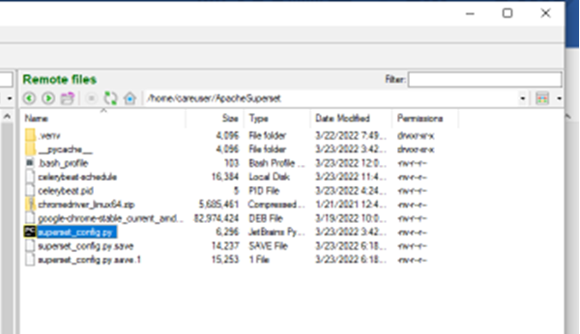

Step 2: To Edit the content of config.py file use below command

$ nano superset_config.py
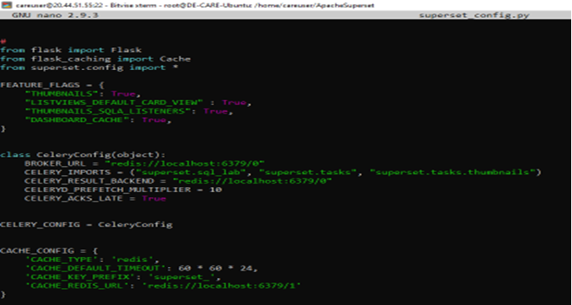

You can edit accordingly and to come out of that “CTRL+X”
It will save the file and run below commands in Linux terminal.
$source .bash_profile
This is directory of superset_config.py file you can confirm by running below command in Linux terminal.
Below comment will initiate freshly for new code.
$ superset init

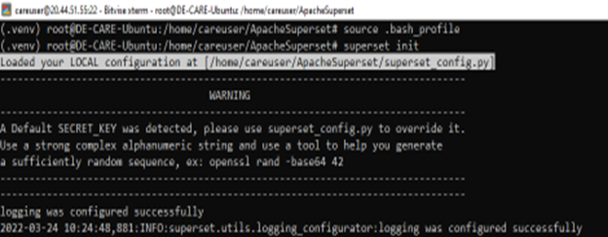

Below command to run Apache superset server:
$superset run -p 8088 -h 0.0.0.0

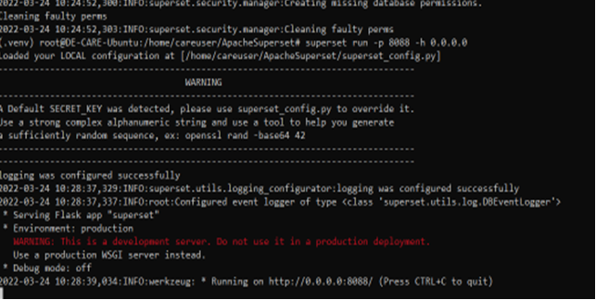

Open superset server in browser and Run sample charts first time that data will come from database when you refresh the same data that data will serve from cache.
Confirmation the cache is working

1.When we browse the chart for first time that will come from database as shown in below picture.

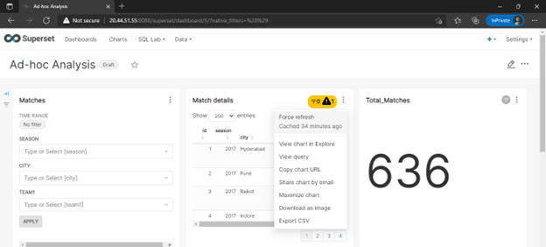

Open Linux terminal and see first time if we are fetching any charts or dashboard it will come from database if we fetch second time it will use the Cache.

Output:

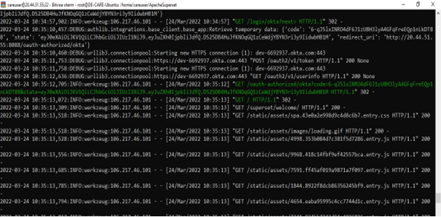

2.For second time when we refresh the same chart or dashboard that will serve from redis cache.

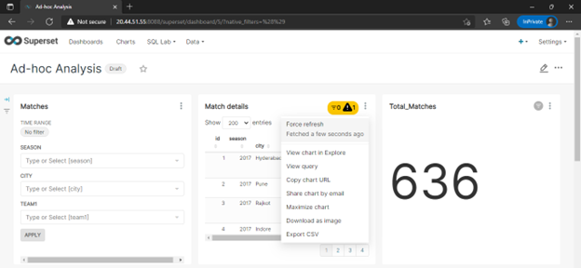

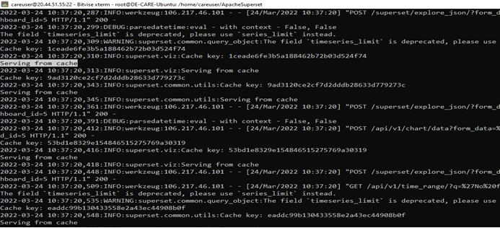

Benefits of Redis cache

The data is coming from cache in above output. some benefits of cache shown below.
- browse fast
- speed up response
- minimize the load on database,
- boost the performance and
- minimize the network call.
Conclusion

Configuring Redis in Superset provides us with the speed retrieval of dashboards and charts. It will save the time and increase the performance as well.

References
- https://superset.apache.org/docs/intro
- https://superset.apache.org
- Introduction | Superset (apache.org)
- Caching | Superset (apache.org)
- https://redis.io/

About the author


Prasanna Parit holds Bachelor’s Degree in Electrical and Electronic Engineering from Dr. Ambedkar Institute of Technology Bangalore. He is currently working as Software Engineer with ERS Research team and involved in Data Engineering products development.

